MongoDB Query Assignment

INSERT DOCUMENTS
Collection Name: students
db.students.insertMany([
{
student_id: 1,
name: "Amit",
age: 20,
marks: 85,
department: "CSE",
subjects: ["DBMS", "OS", "CN"],
email: "amit@gmail.com"
},
{
student_id: 2,
name: "Neha",
age: 22,
marks: 72,
department: "ECE",
subjects: ["Signals", "VLSI"],
email: null
},
{
student_id: 3,
name: "Rahul",
age: 19,
marks: 90,
department: "CSE",
subjects: ["DBMS", "AI", "ML"]
},
{
student_id: 4,
name: "Sneha",
age: 21,
marks: 65,
department: "IT",
subjects: ["Web", "DBMS"],
email: "sneha@gmail.com"
},
{
student_id: 5,
name: "Karan",
age: 23,
marks: 78,
department: "CSE",
subjects: ["CN", "OS"],
email: "karan@gmail.com"
}
]);
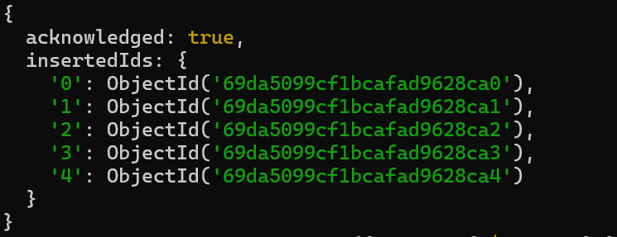
Q1. Find students with marks greater than 80
db.students.find({ marks: { $gt: 80 } })
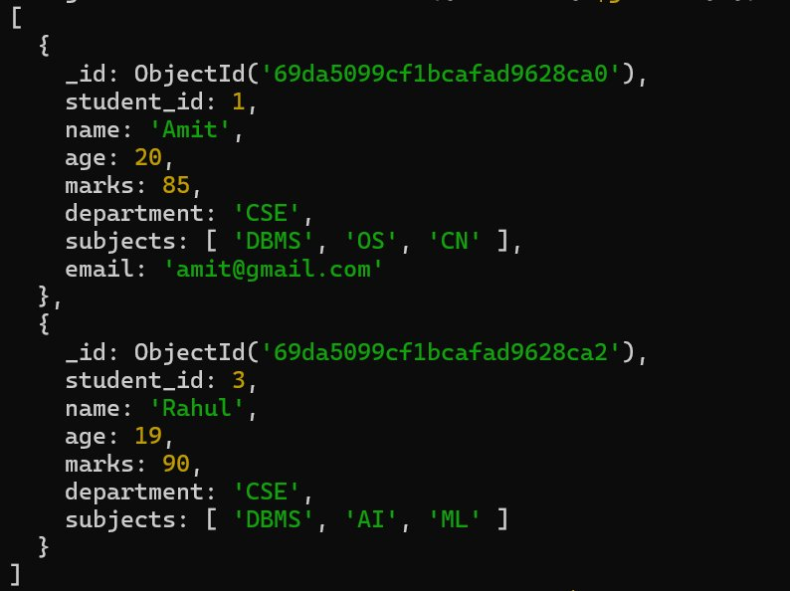
Q2. Find students aged less than or equal to 20
db.students.find({ age: { $lte: 20 } })
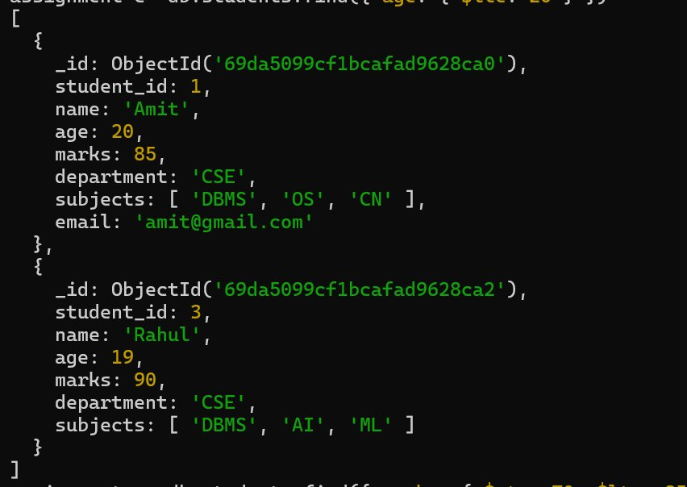
Q3. Find students with marks between 70 and 85

db.students.find({ marks: { $gte: 70, $lte: 85 } })
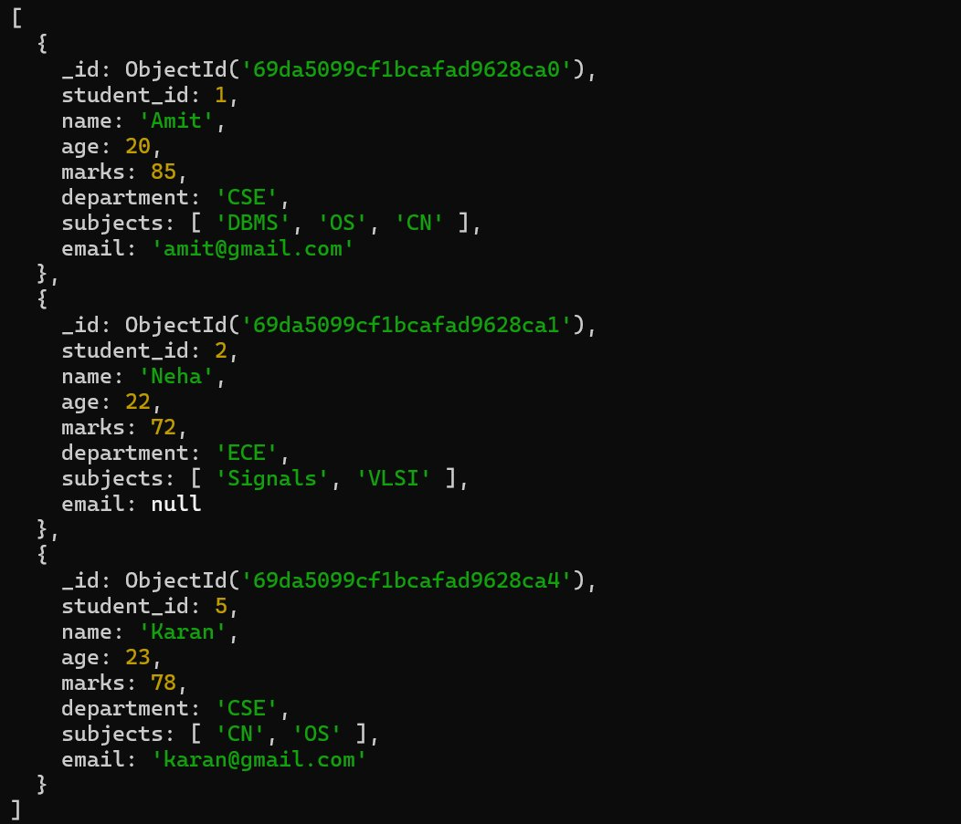

Q4. Find students not belonging to CSE department
db.students.find({ department: { $ne: "CSE" } })
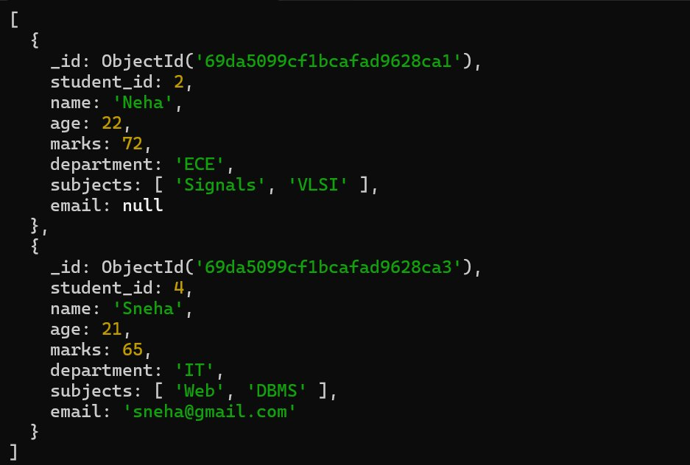

Q5. Find students whose age is exactly 21
db.students.find({ age: 21 })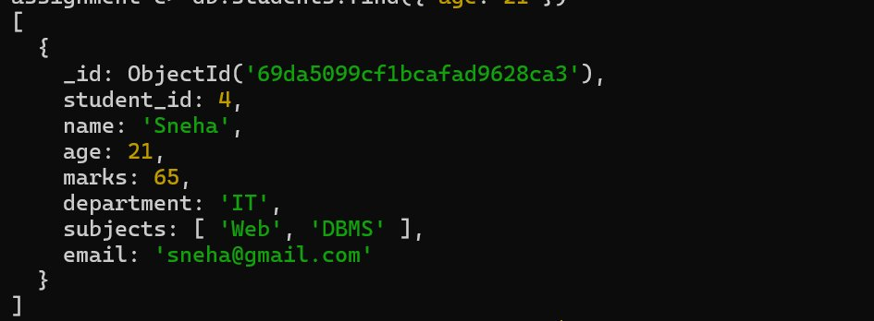

Q6. Find students with marks less than 75
db.students.find({ marks: { $lt: 75 } })
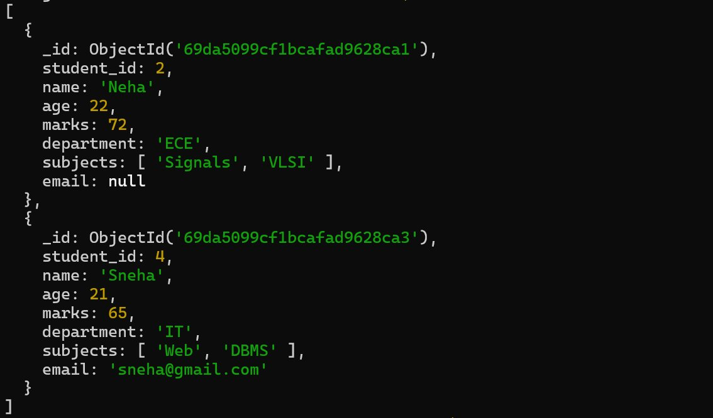

Q7. Find students whose department is either CSE or IT

db.students.find({ department: { $in: ["CSE", "IT"] } })
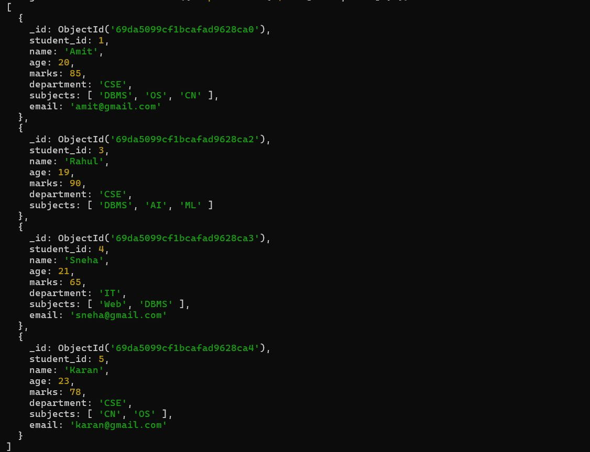

Q8. Find CSE students with marks above 80

db.students.find({ department: "CSE", marks: { $gt: 80 } })
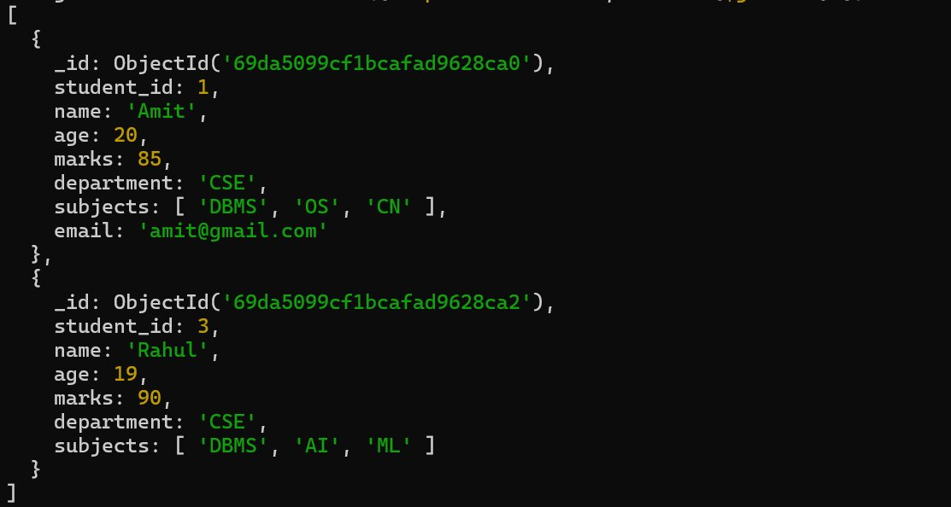

Q9. Find students who are in CSE or have marks above 85

db.students.find({ $or: [ { department: "CSE" }, { marks: { $gt: 85 } } ]})
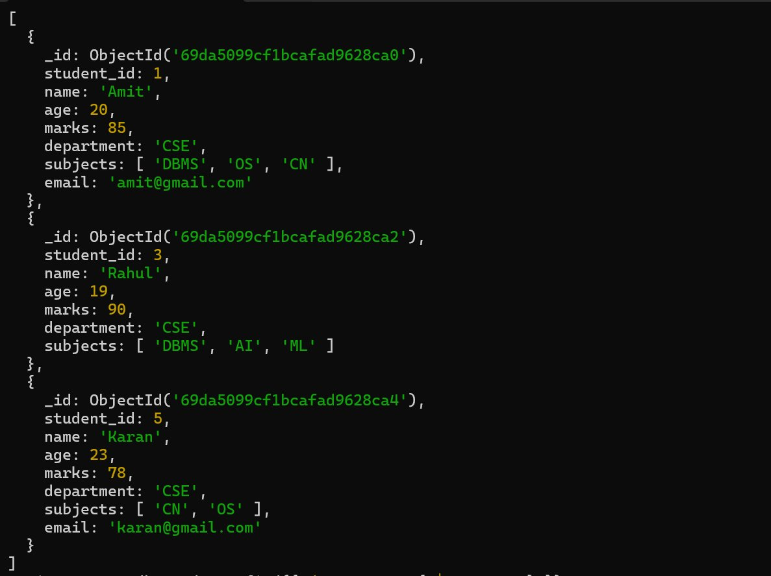

Q10. Find students who are NOT in IT department

db.students.find({ department: { $ne: "IT" } })

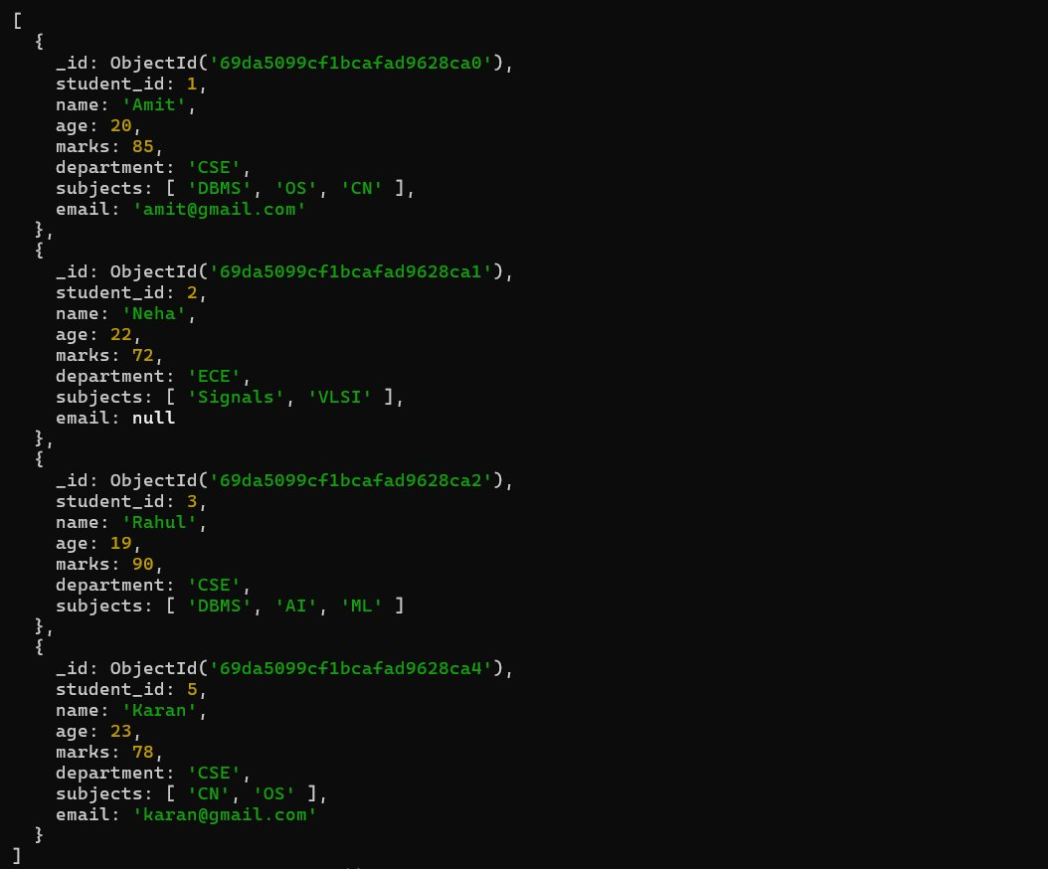

Q11. Find students with marks not between 70 and 85

db.students.find({ $or: [ { marks: { $lt: 70 } }, { marks: { $gt: 85 } } ] })
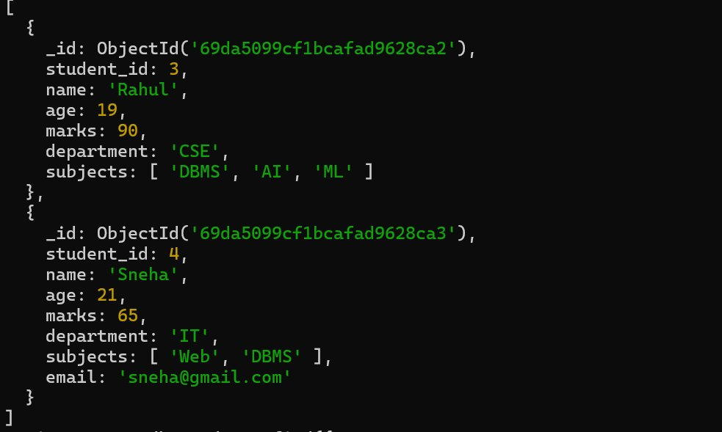

Q12. Find students aged above 20 and not in ECE

db.students.find({age: { $gt: 20 }, department: { $ne: "ECE" }})
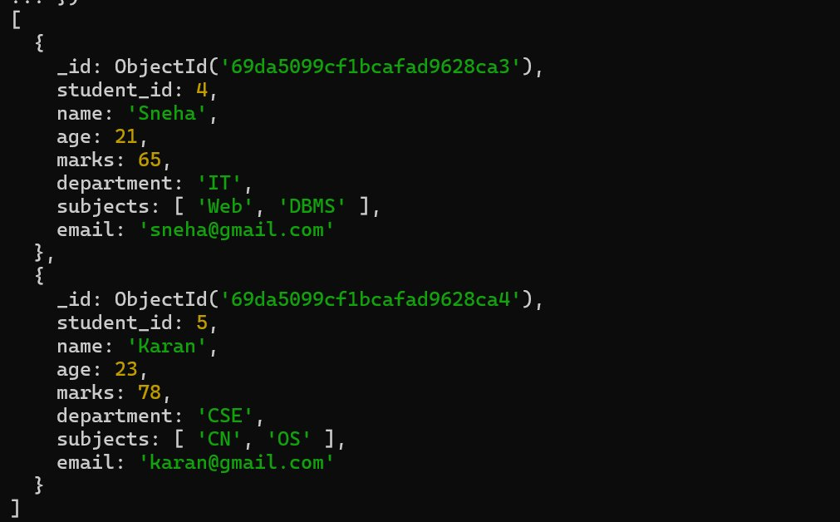

Q13. Find students who are either IT students or have marks less than 70
db.students.find({ $or: [ { department: "IT" }, { marks: { $lt: 70 } } ]})
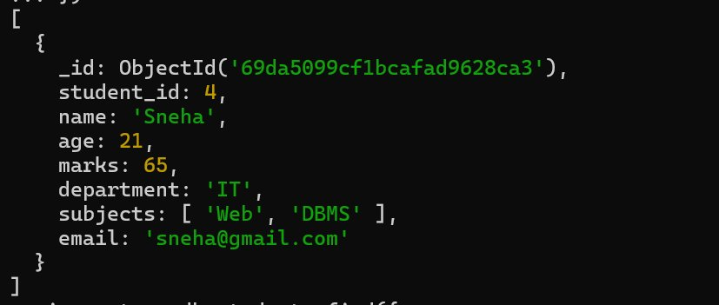

Q14. Find students who are not CSE and not IT
db.students.find({ department: { $nin: ["CSE", "IT"] }})
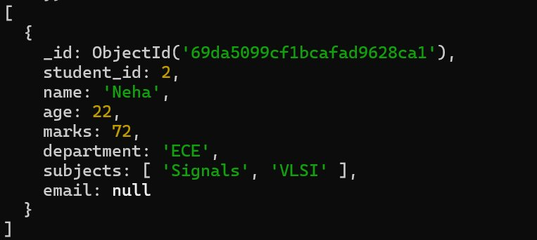

Q15. Find students who have an email field
db.students.find({ email: { $exists: true } })
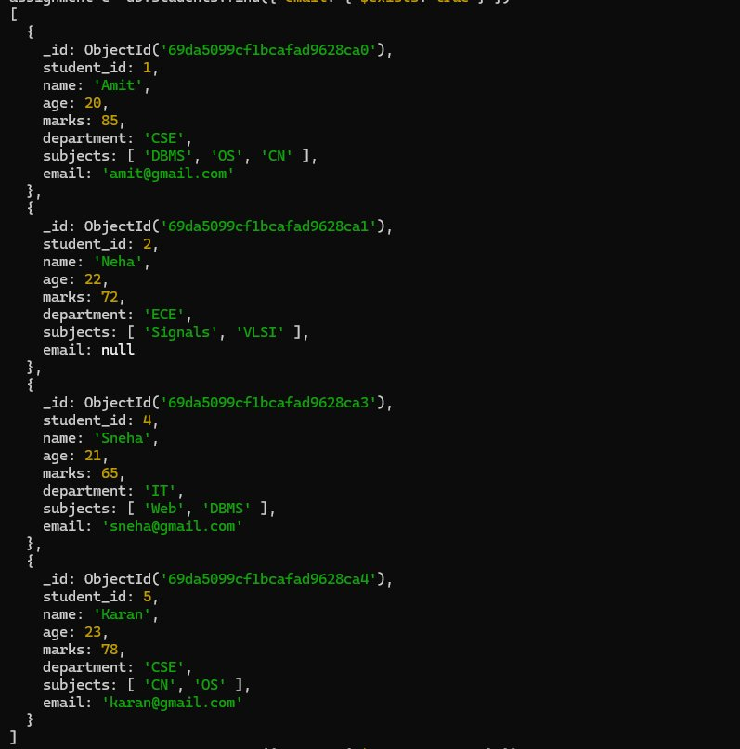

Q16. Find students who do not have an email field

db.students.find({ email: { $exists: false } })
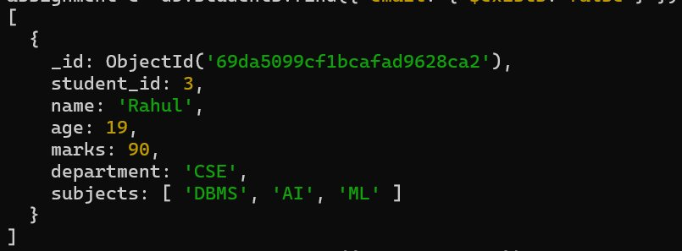
Q17. Find students whose email value is null
db.students.find({ email: null })
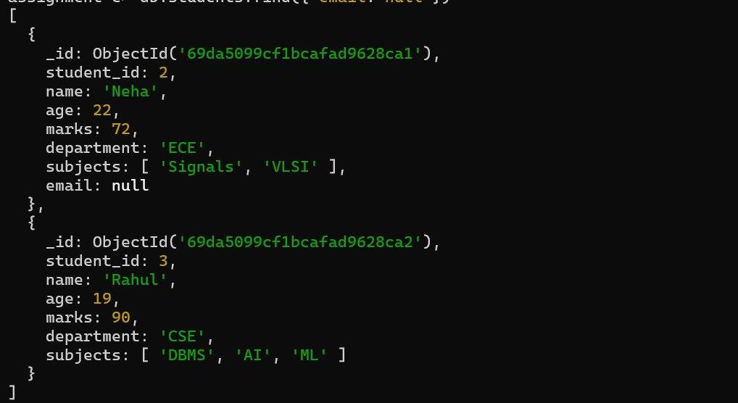

Q18. Find students whose marks field is of type integer

db.students.find({ marks: { $type: "int" } })
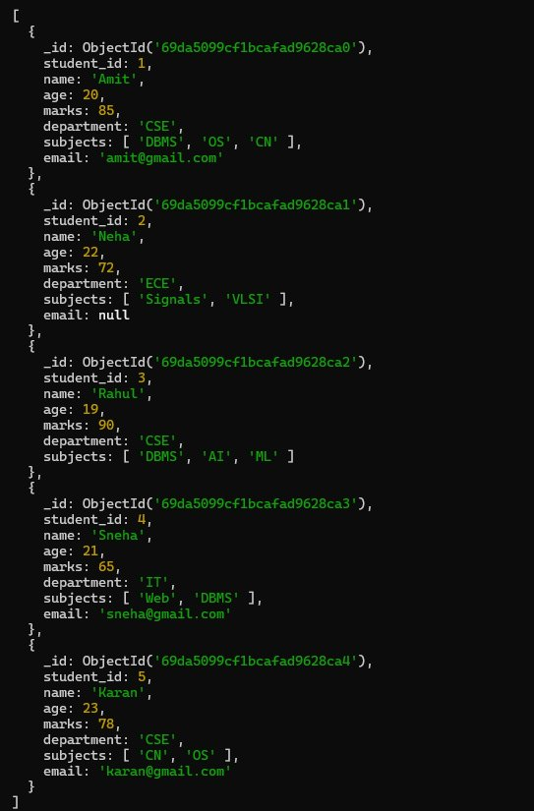
Q19. Find students who have subjects field
db.students.find({ subjects: { $exists: true } })
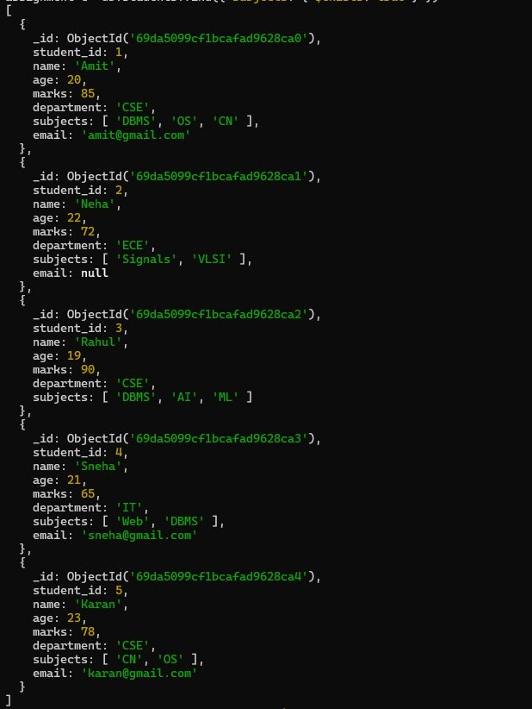

Q20. Find students whose age field is missing
db.students.find({ age: { $exists: false } })
Q21. Find students where marks modulo 5 equals 0
db.students.find({ marks: { $mod: [5, 0] } })
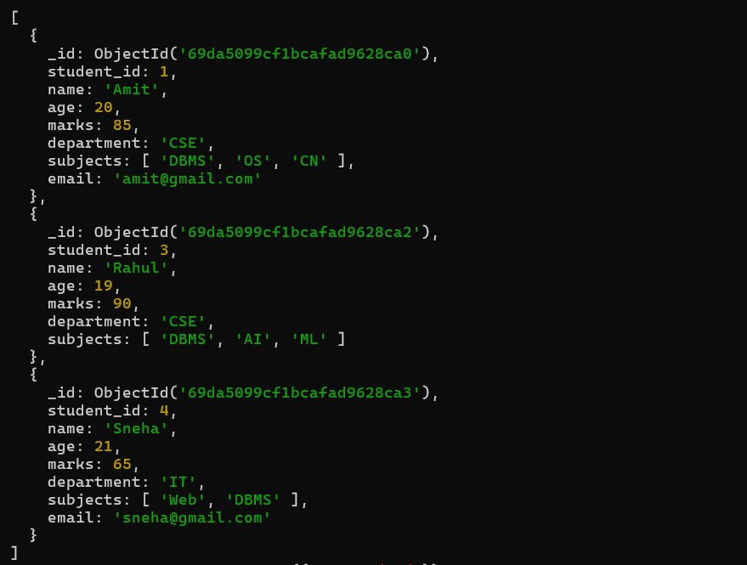

Q22. Find students whose name starts with letter "A"
db.students.find({ name: /^A/ })
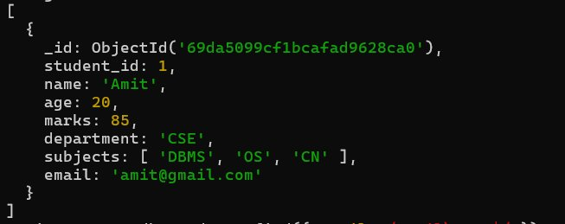

Q23. Find students whose email ends with gmail.com

db.students.find({ email: /gmail\.com$/ })
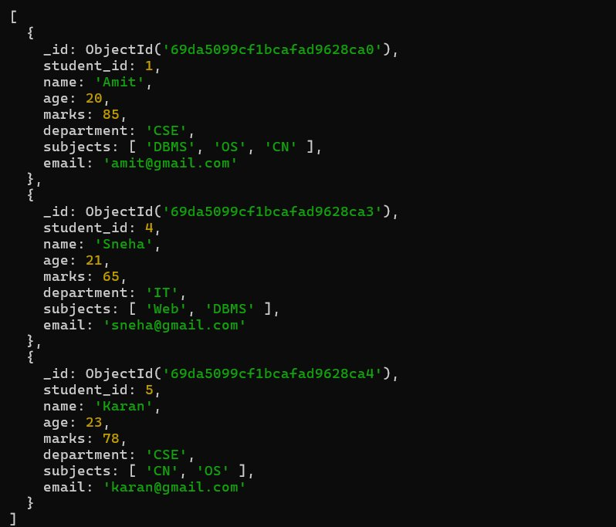

Q24. Find students who have more than 2 subjects

db.students.find({ $expr: { $gt: [{ $size: "$subjects" }, 2] } })
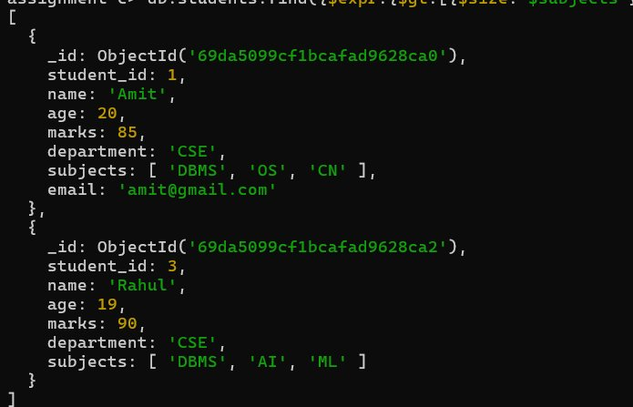

Q25. Find students whose marks are greater than their age × 3

db.students.find({$expr: { $gt: ["$marks", { $multiply: ["$age", 3] }] }})
